**IAM Role Permission Changes Update (GCP Environment)**

10-04-2023 (Wednesday)

As discussed with Pravin Sir in infra meeting 10-04-2023 Shrikant.V & Rahul Patel sir removed **editor** role & added **below** roles permissions for **GCP Developers group** in IAM. (**Project::** qpathways-dev).

API Keys Admin

custom-compute-instance-permission

Secret Manager Secret Version Adder

Service Management Administrator

Viewer

Please refer the below screenshot for more information.

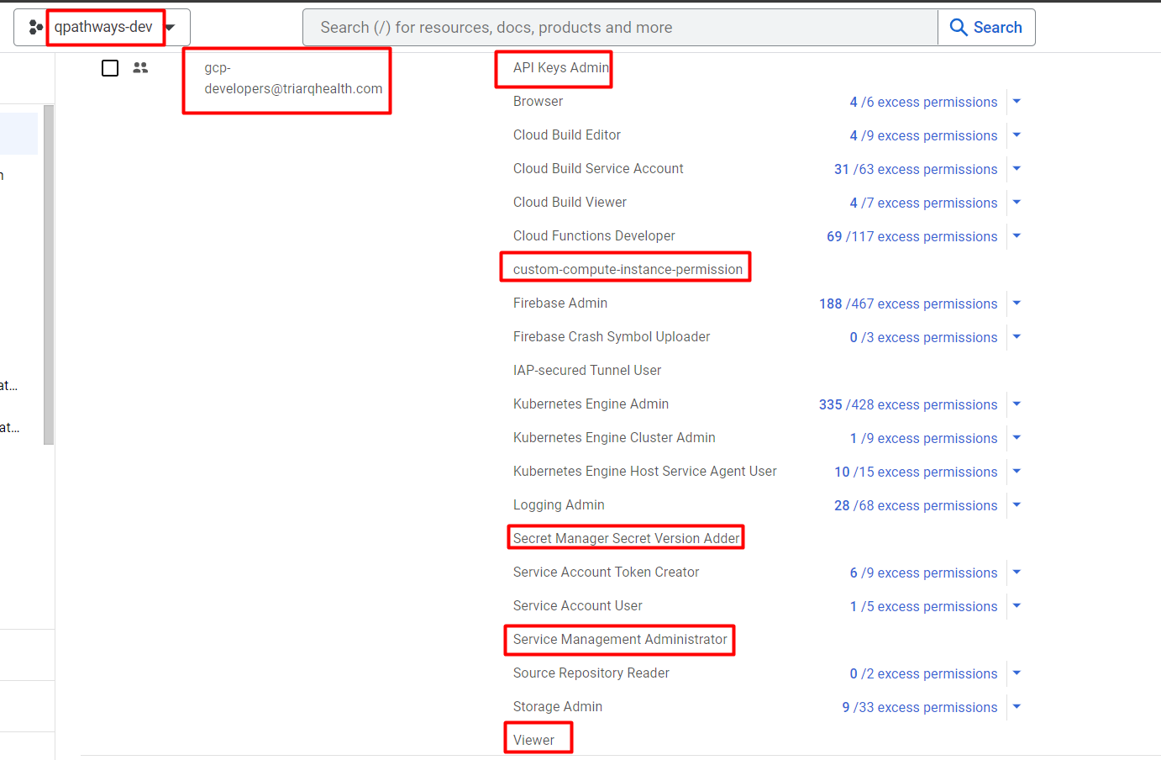

(Date – 10-17-2023)

As discussed with Rahul sir I removed **editor** role & added below roles for **GCP Developers group** in IAM. (**Project ::** qpathways-qa) – (Done by Shrikant)

API Keys Admin

custom-compute-instance-permission

Secret Manager Secret Version Adder

Service Management Administrator

Viewer

 Please refer the below screenshot for your information.

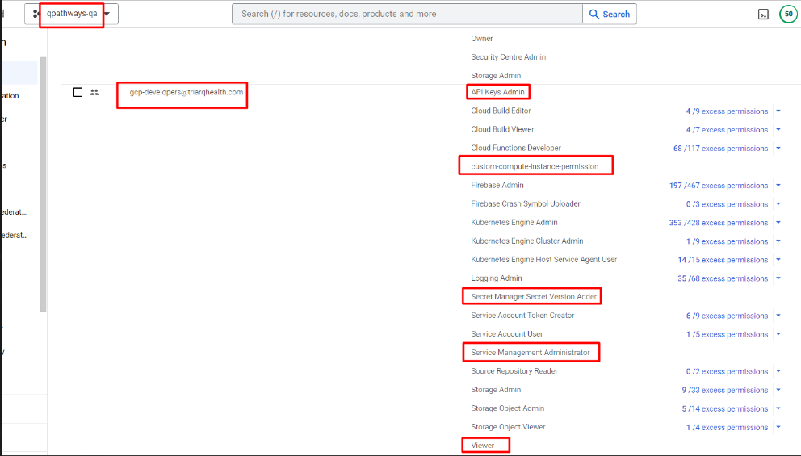

Date – 10-17-2023 (Done by Shrikant)

As per the below email requested in screenshot I discussed with Rahul Sir and created a new [gcpdataflowadmin@triarqhealth.com](mailto:gcpdataflowadmin@triarqhealth.com) group in GCP, assigning this group **Dataflow Admin** role for the DEV, QA, and Staging environments.

We added Pankaj Kumar to the **GCP-Dataflow-Admin** group and confirmed that his issue has been fixed.

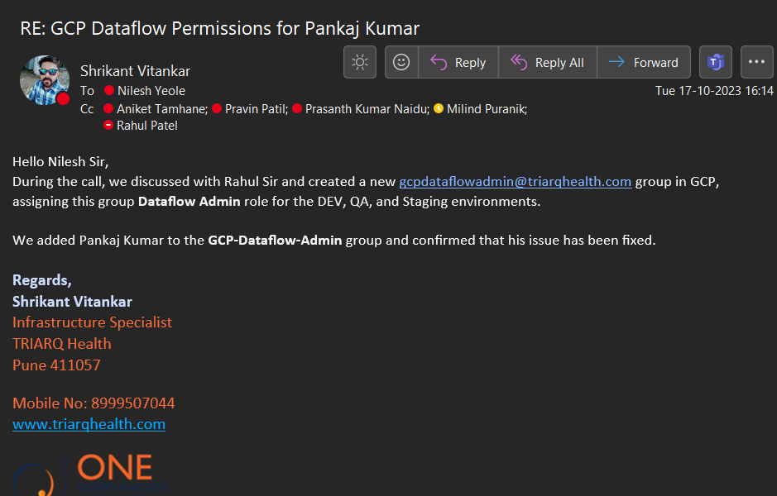

IAM Permission -

As discussed with Rahul sir 30-10-2023 Shrikant.V & Rahul Patel sir removed **editor** role & added **below** roles permissions for **GCP Developers group** in IAM. (**Project:** qpathways-staging).

API Keys Admin

custom-compute-instance-permission

Secret Manager Secret Version Adder

Service Management Administrator

Viewer

Please refer the below screenshot for more information.

In GCP Admin group – Removed kamal puri user because this account was suspended. Date – 30-10-2023 – done by Shrikant.V

IAM review task

Below suspended users has been removed in gcp devops group in gcp (Date – 30-10-2023)

Ajinkya Deshmukh

Madhavi Sontakke

Mahesh Nawal

Priyanka Gavit

Santosh Joshi

Sharad Bhagat

Sneha Pandit

Tejashree Ambhorkar

Vrushali Shinde

(Date –7th Nov 2023)

Milind Puranik discussed with Rahul sir & he removed **editor** role & added below roles for [**GCP Dev-Prod**](https://admin.google.com/ac/groups/01pxezwc1ncrozg) **Group** in IAM. (**Project ::** qpathways-prod) – (Done by Milind Puranik )

API Keys Admin

custom-compute-instance-permission

Secret Manager Secret Version Adder

Service Management Administrator

Viewer

 Please refer the below screenshot for your information.

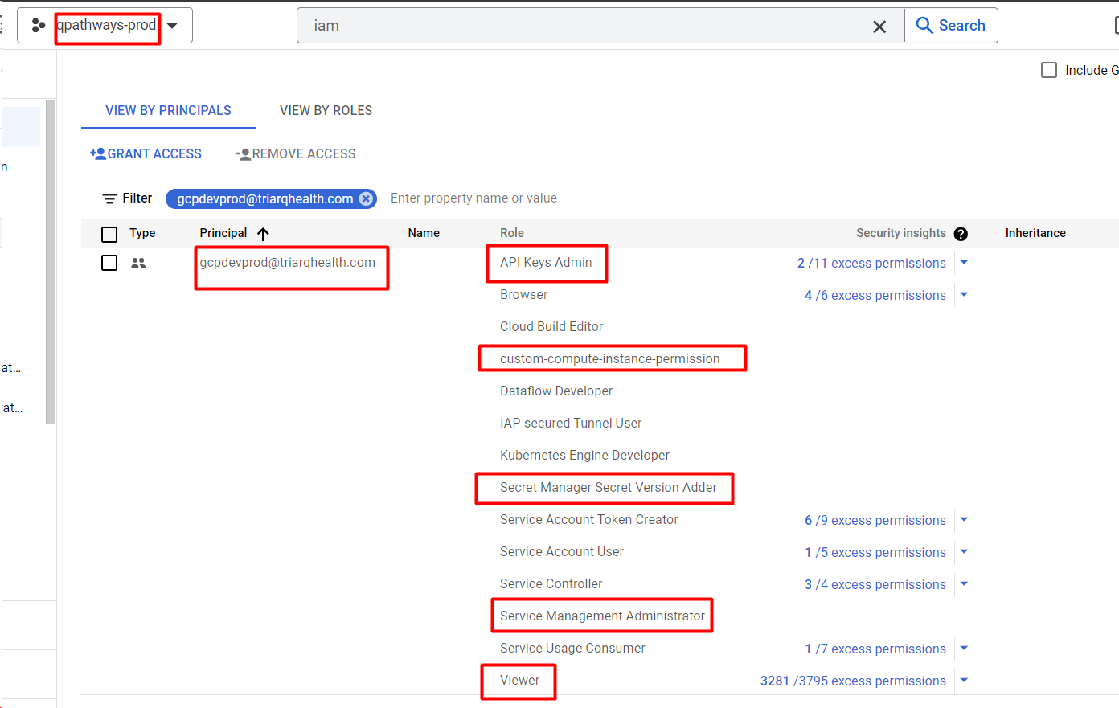

Remove permissions of Mediaagility email IDs on Org level in IAM & provided permissions as per project level. (Date – 9th Nov 2023) – Done by Shirkant.V.

Project Name: qpathways-dev – Done.

I removed [cloud-architect@mediaagility.com](mailto:cloud-architect@mediaagility.com) email ID from Organization level & added this email ID in qpathways-dev IAM for project wise permission with editor role. (Same permissions assigned for qa, staging & prod environment).

Note :: Discussed with Rahul Patel Sir I provided editor role for project level instead of owner role which was previously assigned for org level.

Org level previous permission-

Org level previous permission-

Org level previous permission-

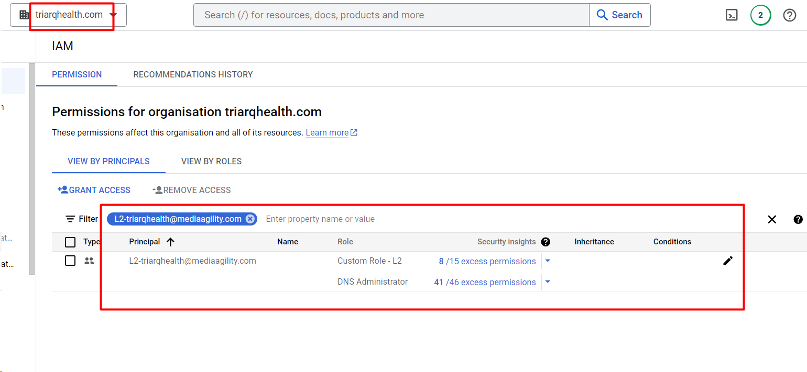

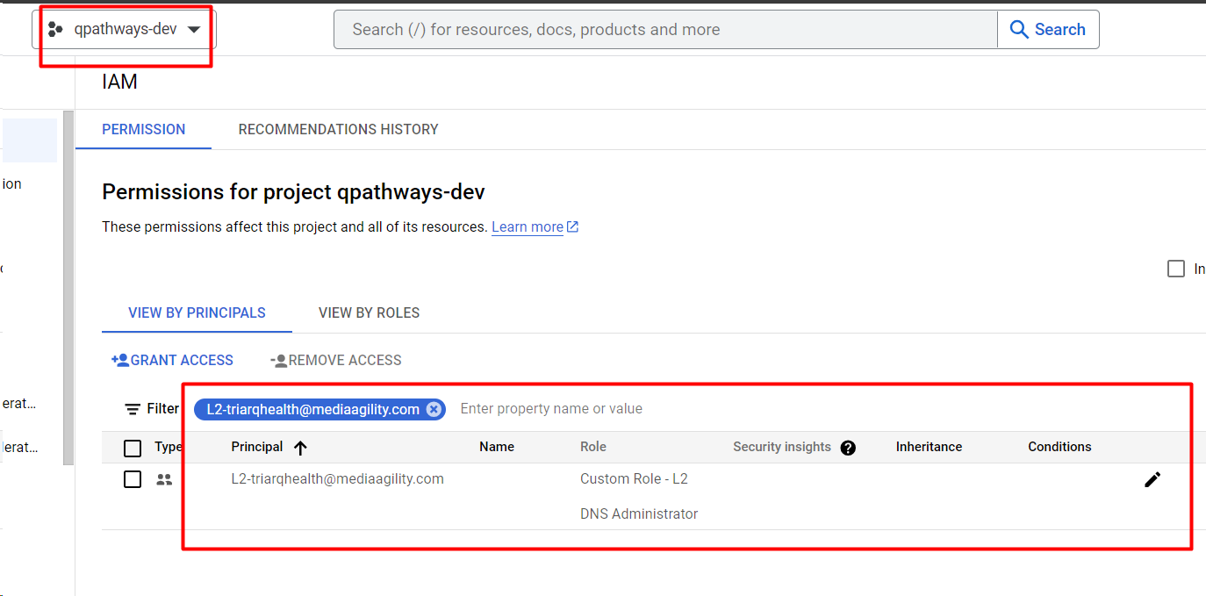

Custom Role – L1 - I created custom role Custom Role – L1. In the org level below sub roles had been added but when I am assigning this role as project wise only 10 roles supported.

Description - This role has been created for mediaagility team for this project permission.

Not applicable status role has been not supported for project level permission.

compute.instances.get

compute.instances.list

compute.instances.start

compute.instances.stop

resourcemanager.projects.get

resourcemanager.projects.list - Not applicable (Unable to select).

storage.buckets.list

storage.objects.create

storage.objects.delete

storage.objects.get

storage.objects.list

Custom Role - L2 - I created custom role Custom Role - L2. In the org level below sub roles had been added but when I am assigning this role as project wise only 14 roles supported.

Not applicable status role has been not supported for project level permission.

compute.firewalls.get

compute.firewalls.list

compute.firewalls.update

compute.instances.create

compute.instances.get

compute.instances.list

compute.instances.start

compute.instances.stop

resourcemanager.projects.get

resourcemanager.projects.list - Not applicable (Unable to select).

storage.buckets.list

storage.objects.create

storage.objects.delete

storage.objects.get

storage.objects.list

Org level previous permission-

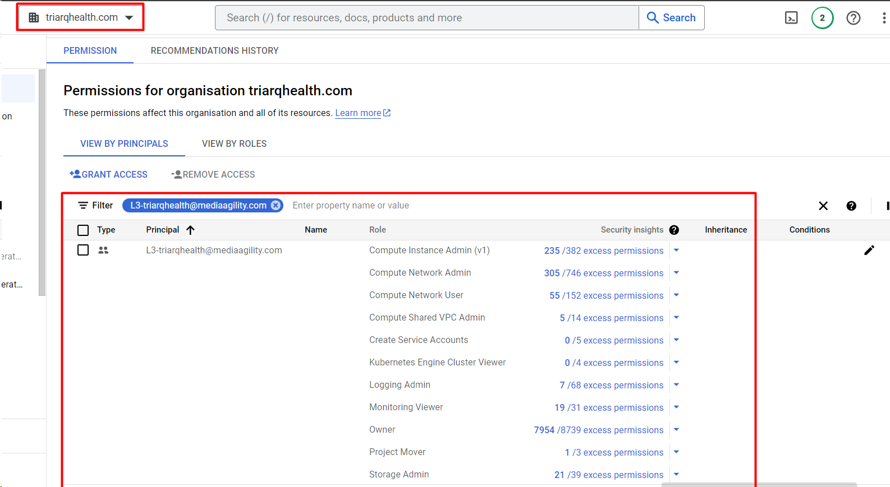

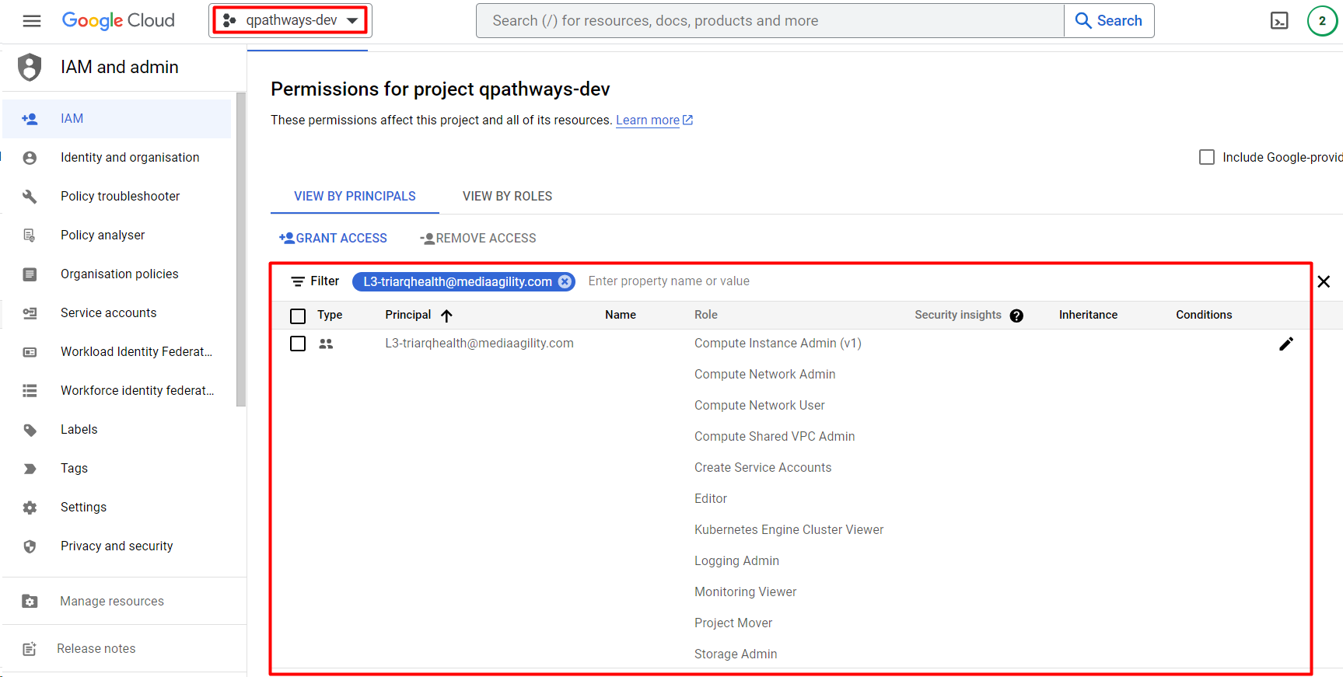

Note:: I created custom role of Compute Shared VPC Admin. In the org level below sub roles had been added but when I am assigning these roles as project wise only 7 roles supported.

Not applicable & not supported roles has been not supported for project level permission.

Compute Shared VPC Admin -(Custom role)

Description - Can administer shared VPC network (XPN). This role has been created for mediaagility team for this project permission.

compute.globalOperations.get

compute.globalOperations.list

compute.organizations.administerXpn - Not supported (Unable to select)

compute.organizations.disableXpnHost - Not applicable (Unable to select)

compute.organizations.disableXpnResource - Not applicable (Unable to select)

compute.organizations.enableXpnHost - Not applicable (Unable to select)

compute.organizations.enableXpnResource - Not applicable (Unable to select)

compute.projects.get

compute.subnetworks.getIamPolicy

compute.subnetworks.setIamPolicy

resourcemanager.organizations.get - Not applicable (Unable to select)

resourcemanager.projects.get

resourcemanager.projects.getIamPolicy

resourcemanager.projects.list - Not applicable (Unable to select)

Project: qpathways-qa – Done.

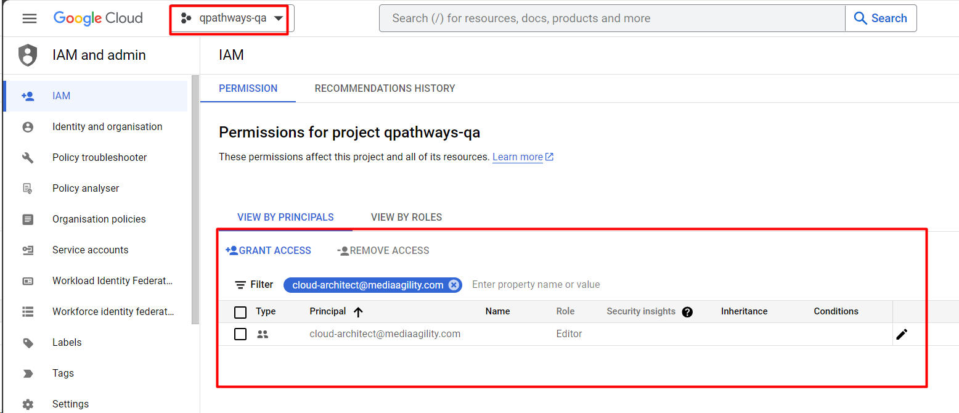

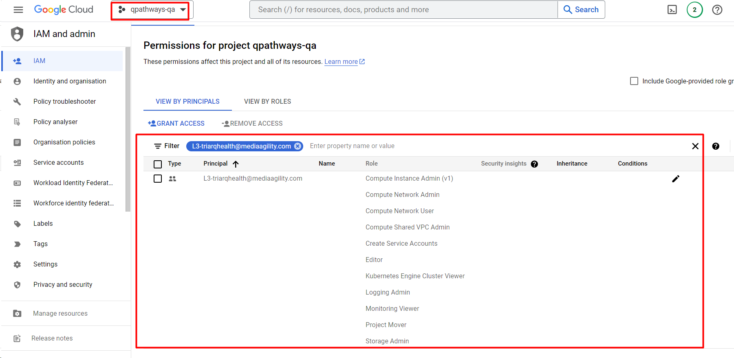

Project: qpathways-staging – Done.

Note:: [L3-triarqhealth@mediaagility.com](mailto:L3-triarqhealth@mediaagility.com) email ID had already created for this project with Service Account User permission as per project wise.

Project: qpathways-prod – Done.

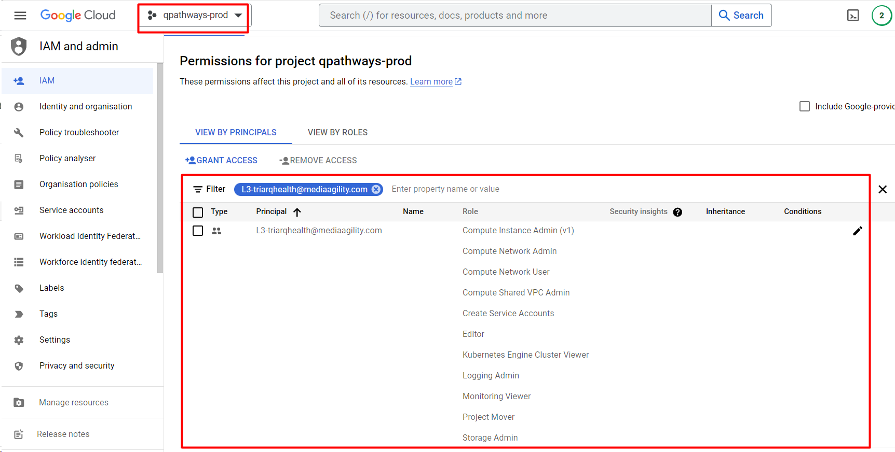

Note:: I created below custom role for Dev, qa, staging & prod environment in IAM.

Custom Role - L1

Custom Role - L2

Compute Shared VPC Admin

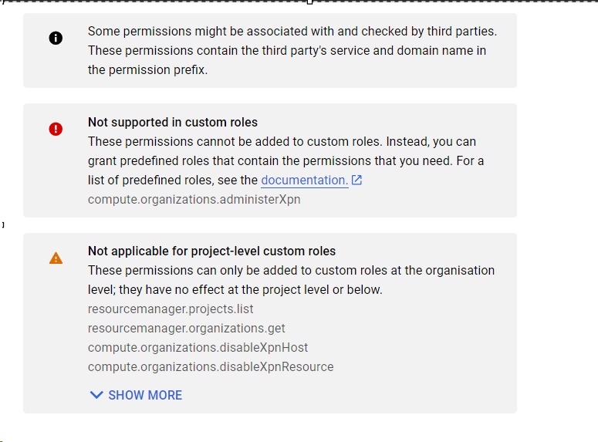

Date – 16-11-2023 (Done by Shrikant.V)

As discussed with Rahul Patel Sir I removed editor permissions for [firebase-adminsdk-wk2dl@qpathways-dev.iam.gserviceaccount.com](mailto:firebase-adminsdk-wk2dl@qpathways-dev.iam.gserviceaccount.com) service account in qpathways-dev project & created custom role Firebase admin SDK Permission & provided below role permissions which was previously usable for editor permission.

4 assigned permissions for custom role - Firebase admin SDK Permission

* firebaseauth.users.create
* firebaseauth.users.get
* firebaseauth.users.sendEmail
* firebaseauth.users.update

Previous permission screenshot is given below –

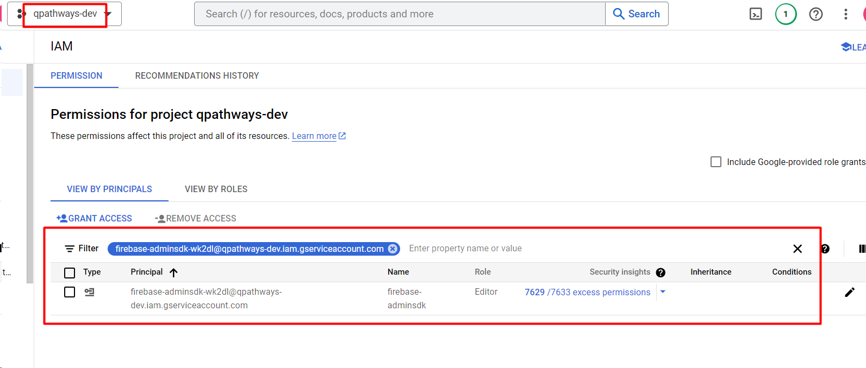

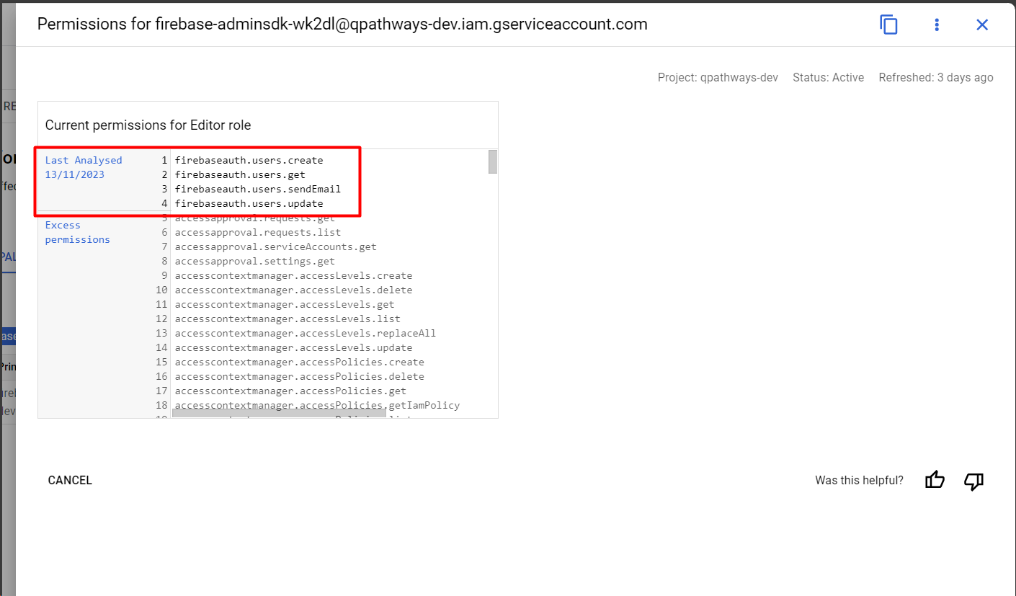

After provided custom role permission - Firebase admin SDK Permission. Please refer the below screenshot for more information.

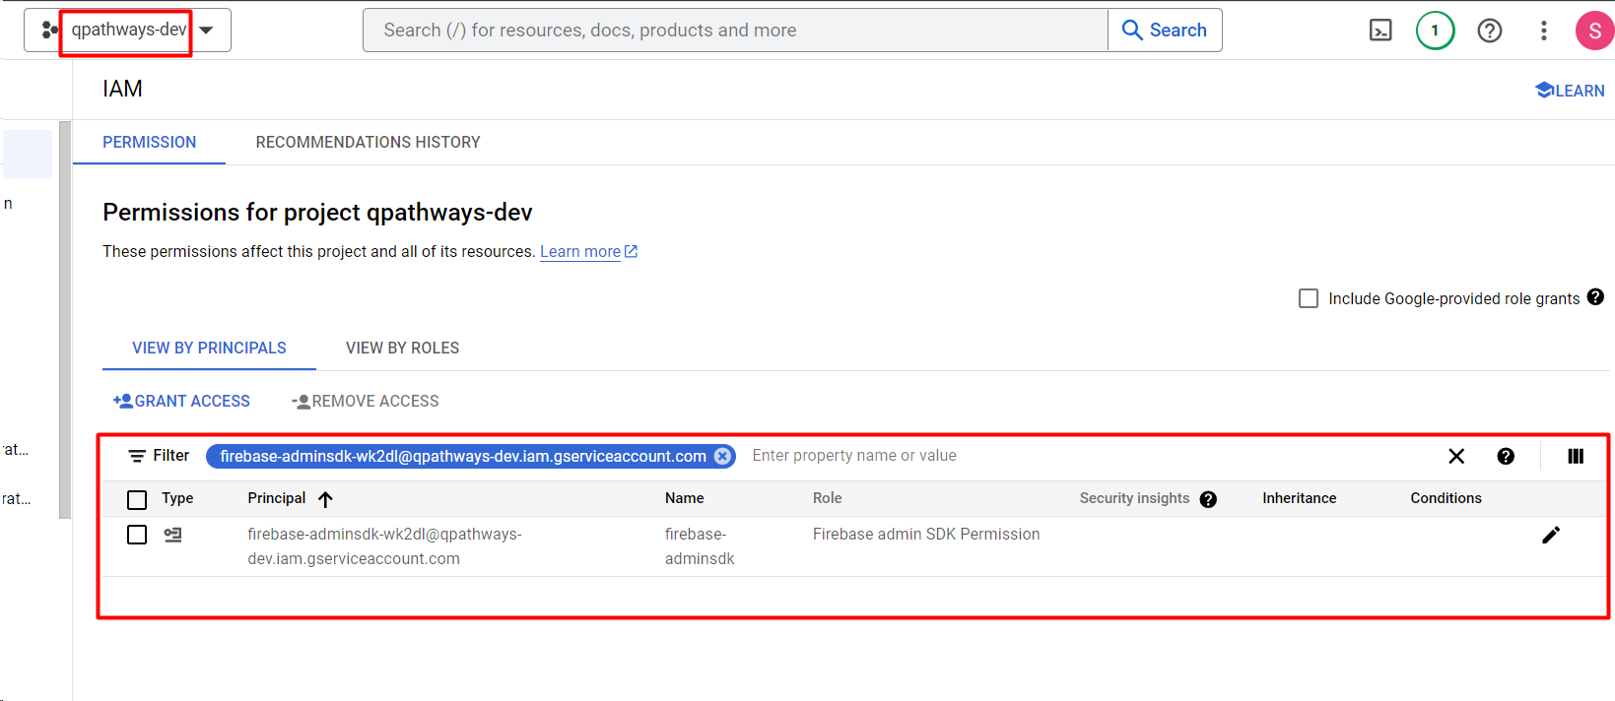

Date – 17-11-2023

As discussed with you I removed [bcbsm-devops@triarqhealth.com](mailto:bcbsm-devops@triarqhealth.com) group permission on bcbsm-dev project & added on bcbsm folder level.

Please refer the below screenshot more information. (Done by Shrikant.V)

Before permission screenshot which we have removed.

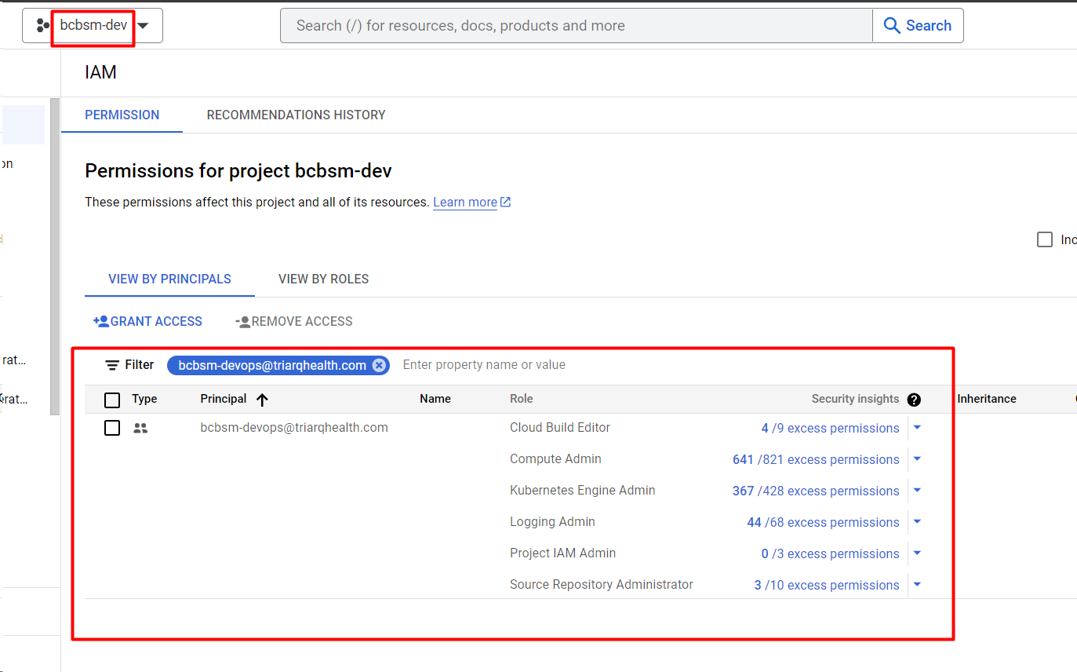

After screenshot which we have added.

Date – 20-11-2023 (Done by Shrikant.V) – 20-11-2023

As discussed with Rahul Sir as per **Yogesh Khaire Sir & Qinsights** teams’ requirement we have created below group in GCP Admin panel.

**For Triarq Project**

GCP BigQuery

gcp-bigquery@triarqhealth.com

GCP-Dataflow-Admin

gcpdataflowadmin@triarqhealth.com (This group has been already created).

**For bcbsm project**

bcbsm bigquery

bcbsm-bigquery@triarqhealth.com

bcbsm dataflow

[bcbsm-dataflow@triarqhealth.com](mailto:bcbsm-dataflow@triarqhealth.com)

Triarq GCP Project -

Email request:: RE: Big Query audit log view permissions on all environments ( Done by Shrikant. V) 20-11-2023 & 21-11-2023

Yogesh Khire and Priyanka Suryawanshi has permission to see audit logs from Big query, which look-s like now not available so I added Yogesh Khaire and Priyanka Suryavanshi to the **GCP BigQuery** -group that I created, and I also gave this group access to **bigquery.tables.get**, **viewer, BigQuery Data Viewer** permission for the dev, prod, staging, and qa environments.

Date – 21-11-2023

**I enabled serverless VPC Access API for create the serverless VPC access connector for th-corporate project.  (As per the AIML team request – Roshan Gaikwad).**

**Date – 27-11-2023 (Done by Shrikant.V) Email subject :: RE: Request for GCP Edit Permission for Cloud Function on Production**

**As per Swapnil Ahire email request I discussed with DevOps team (Prasanth Naidu Sir) & provided** **Cloud Functions Developer** role to GCP Developers group for **qpathways-prod** project. Please refer the below screenshot for more information.

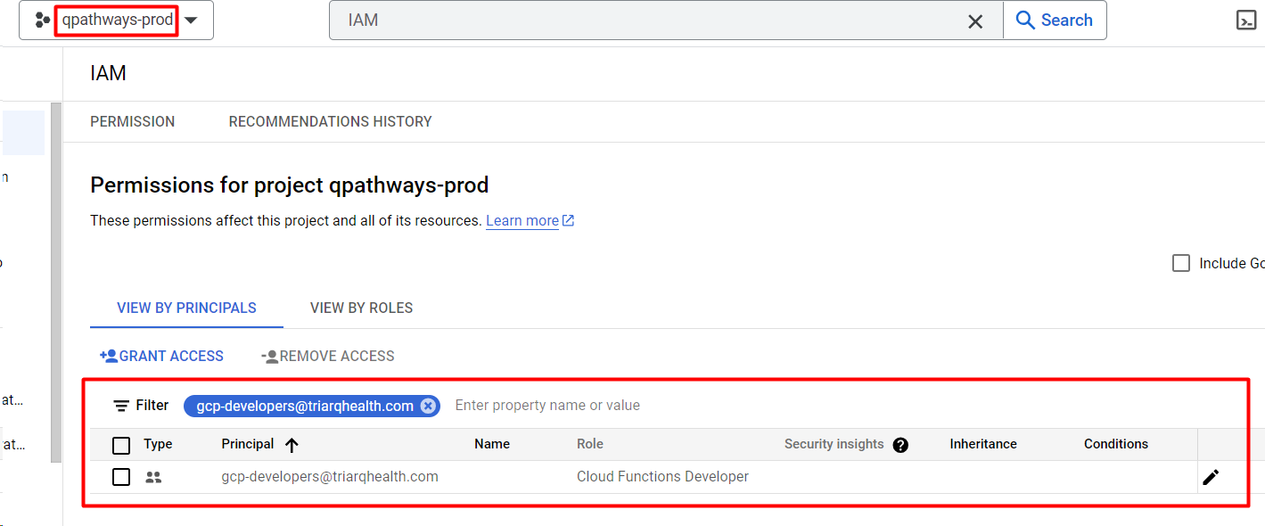

Date – 30-11-2023

As per our conversation with Rahul Patel Sir and his requirement, I have added Aniket Arghode to the GCP Admin group. (Project Triarq).

Date – 05-12-2023 (Done by Shrikant. V) Night Shift.

Dennis informed us he received a firewall rule alert for the wiz outpost project. He was getting an error when he attempts to access the link.

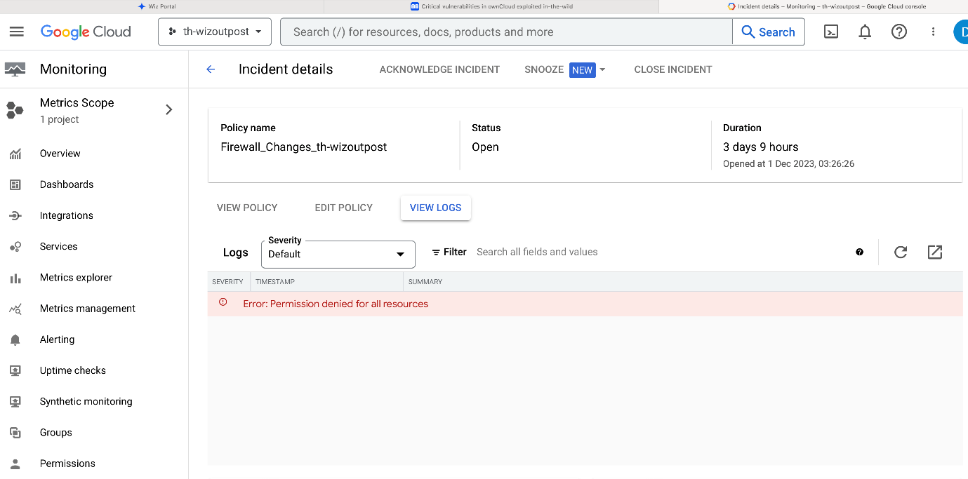

I provided Security Admin & Security center Admin role permission on project level to gcp security admin group for the th-wizoutpost project. Dennis have part of this group.

(Checked on qpathways-staging project because these two permissions is showing same).

After assigned this permissions Dennis informed me his issue has been resolved.

